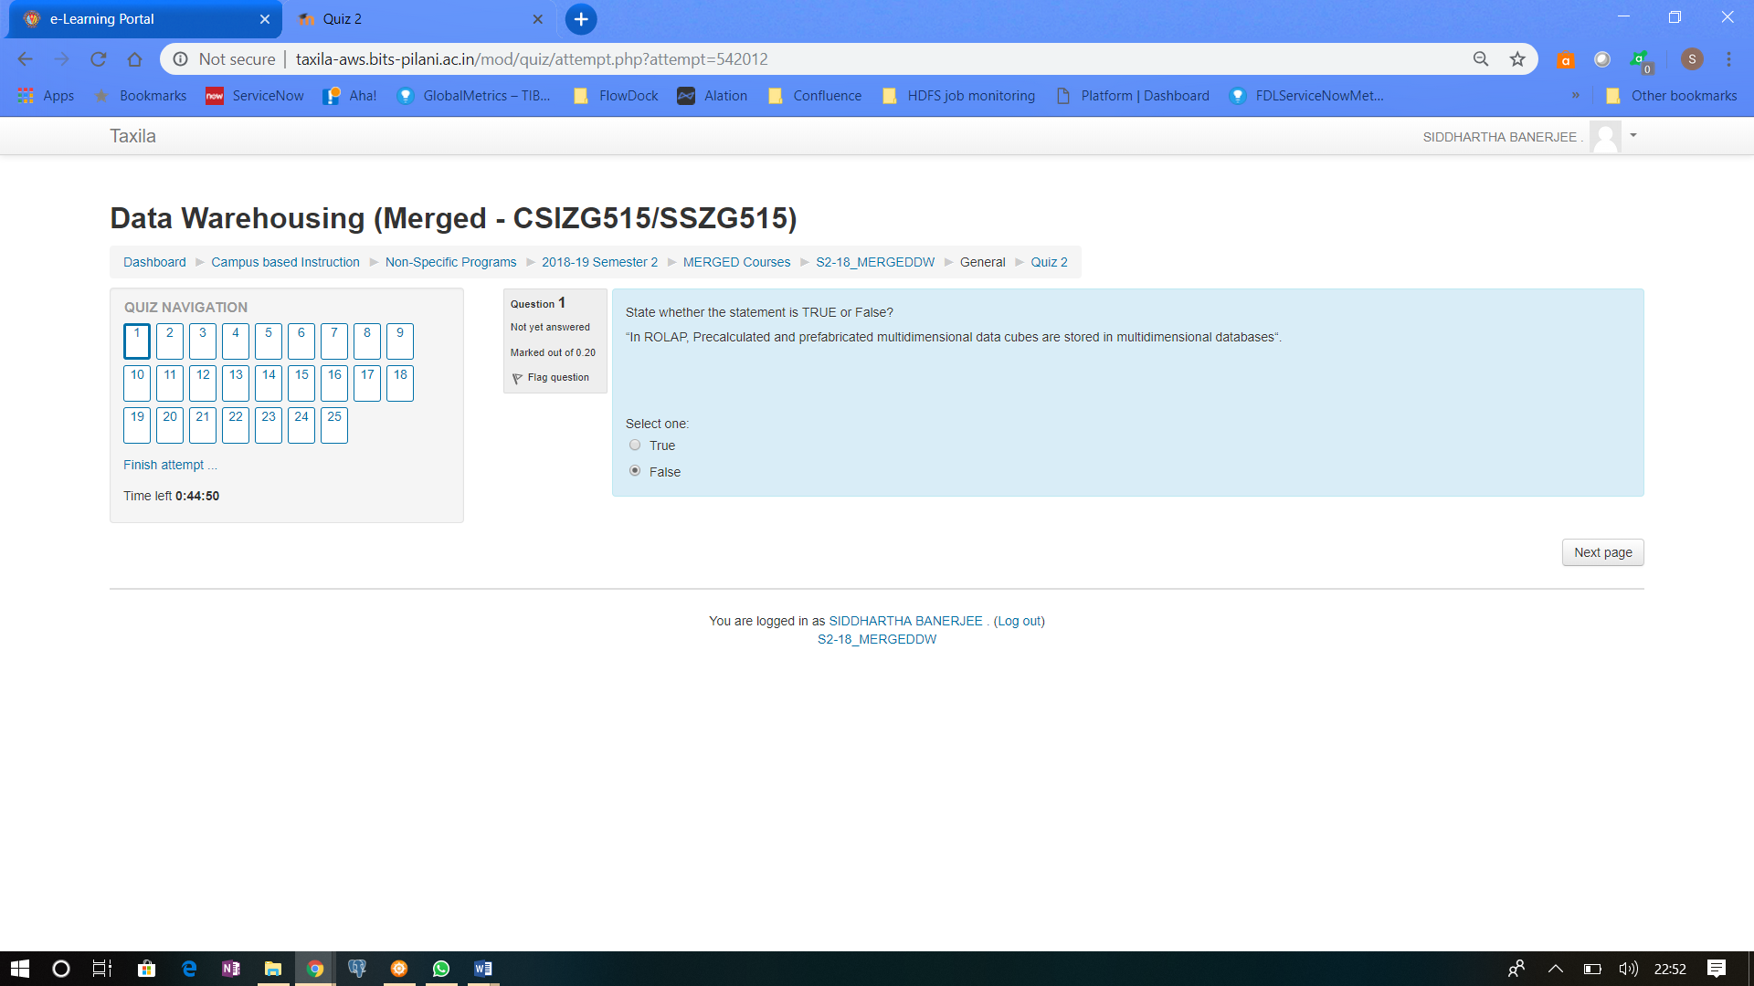

ROLAP is Relational online analytical processing (**ROLAP**) is a form of online analytical processing (OLAP) that performs dynamic multidimensional analysis of data stored in a relational database rather than in a multidimensional database (which is usually considered the OLAP standard).

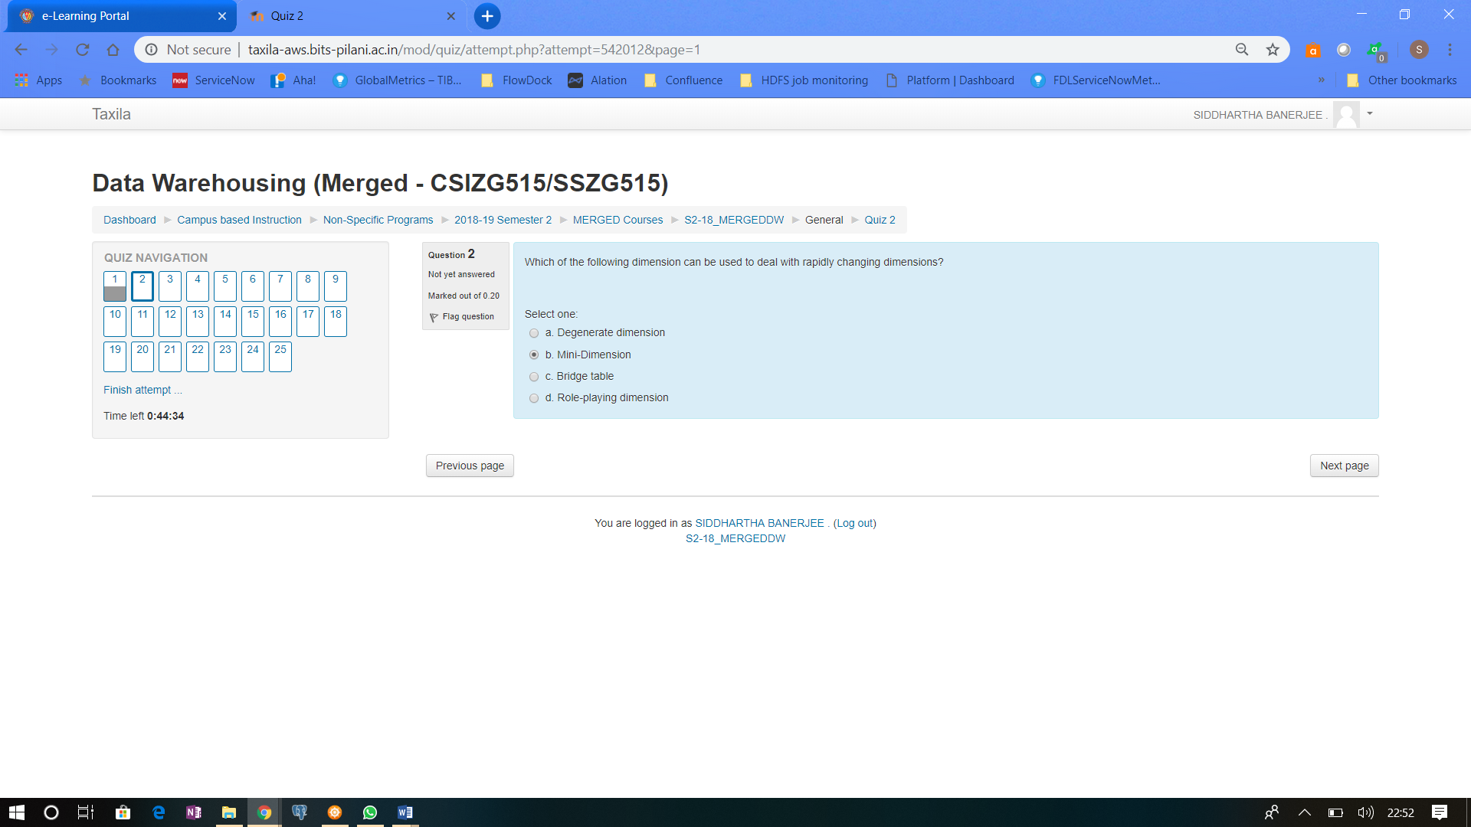

Mini dimension are created out of Rapidly Changing dimension so as to reduce the volume up of update & delete

Q3 -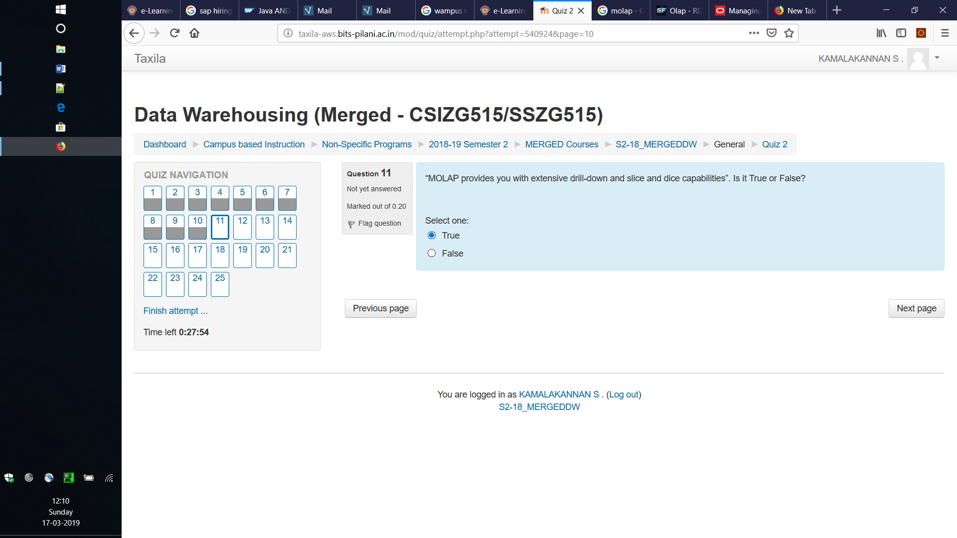 <https://searchsqlserver.techtarget.com/definition/MOLAP>

<https://www.guru99.com/multidimensional-online-analytical-processing.html>

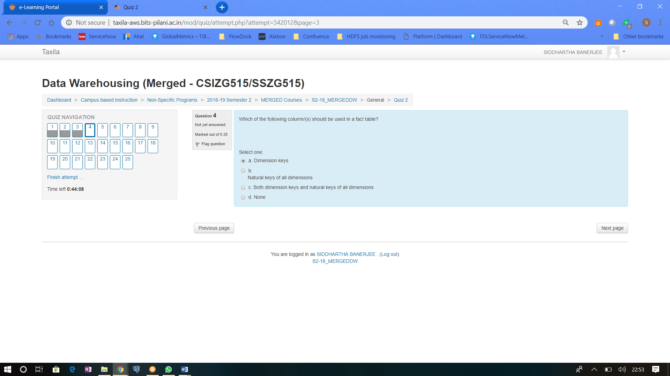

Dimension keys are synonyms for Surrogate keys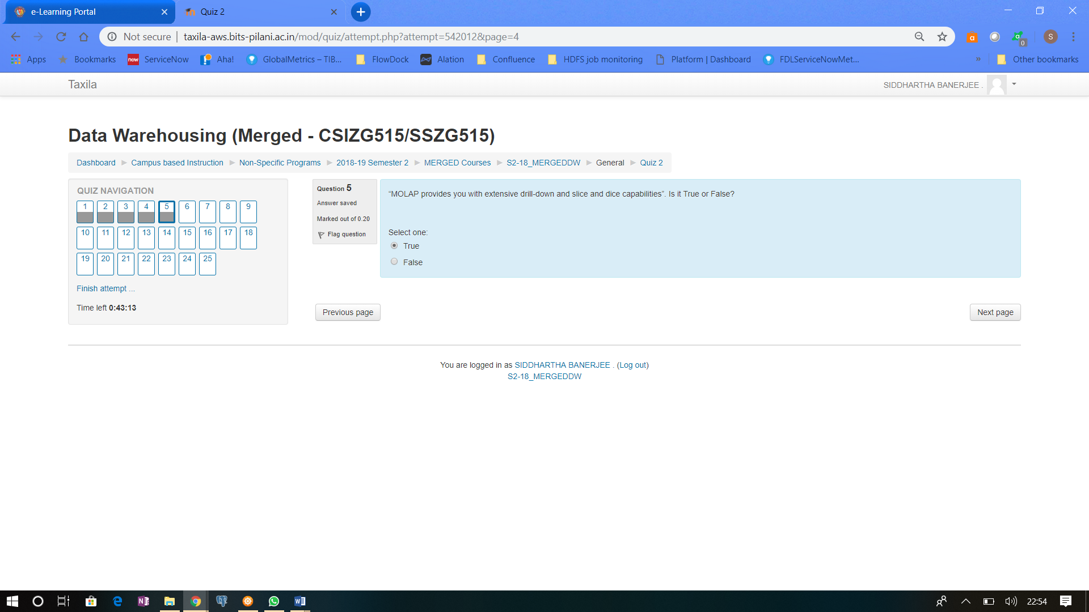

<https://www.teradatapoint.com/data-warehousing-molap>

<https://www.guru99.com/multidimensional-online-analytical-processing.html>

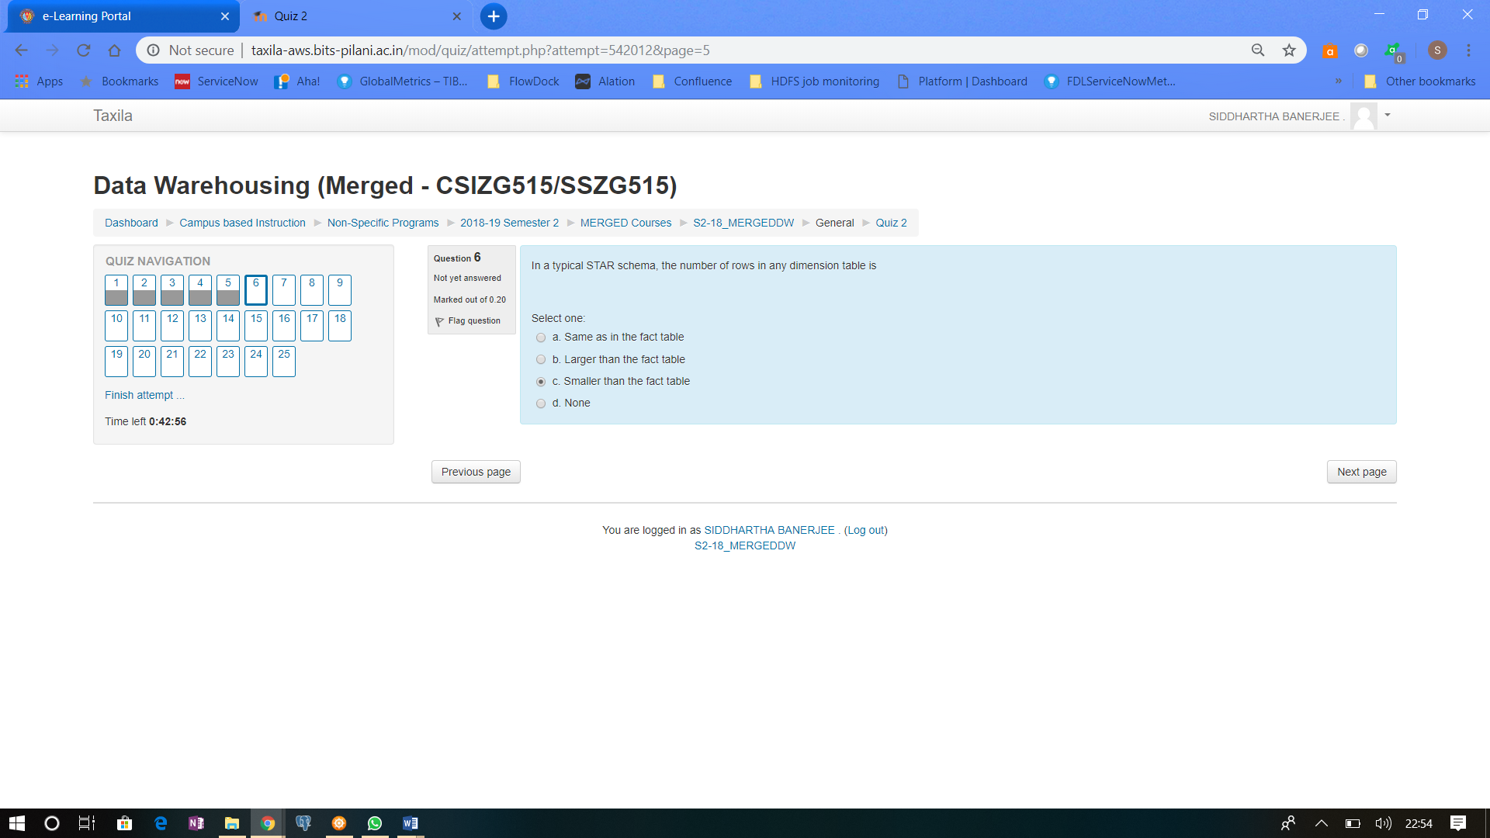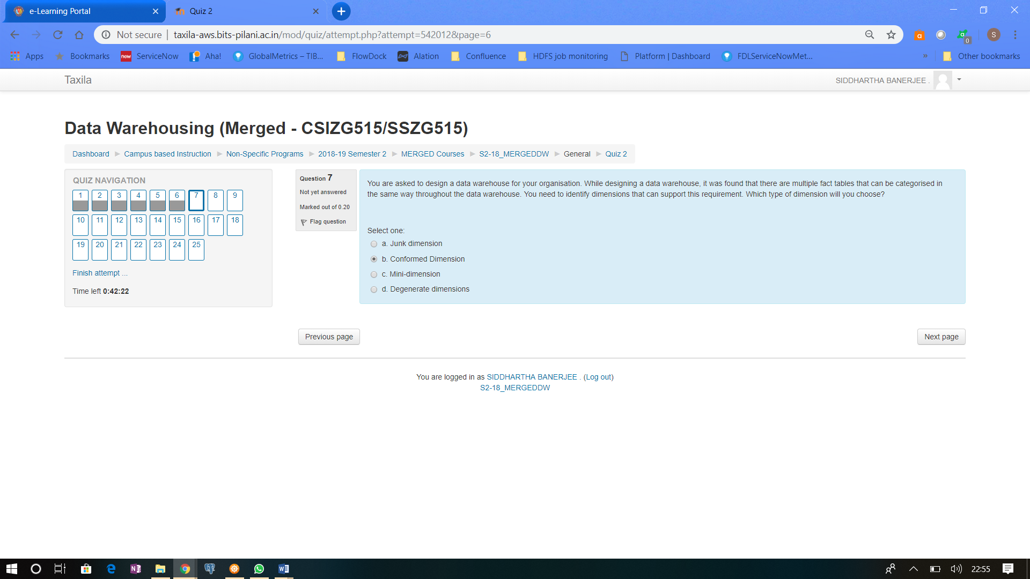

Confirmed Dimensions are like Master list of items – It can be used in Invoicing, it can be used in Purchased orders, it can be used in Order details..etc…so 3 different subject area – Finance, Procurement & Order management

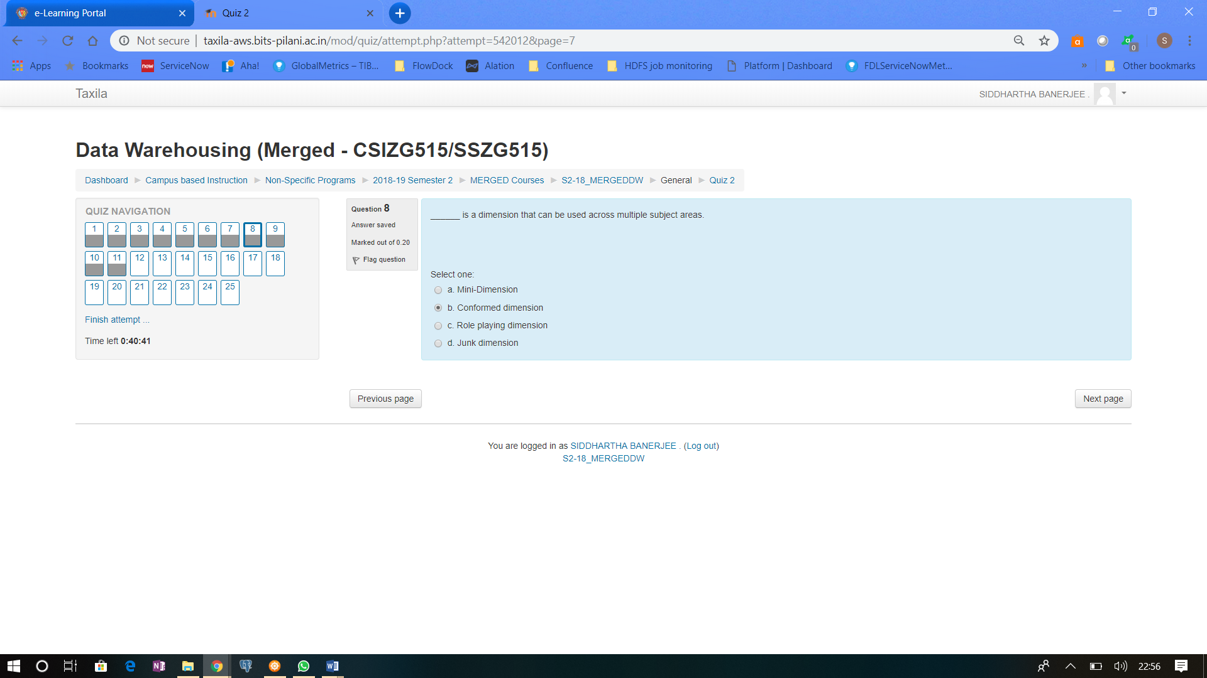

Same as above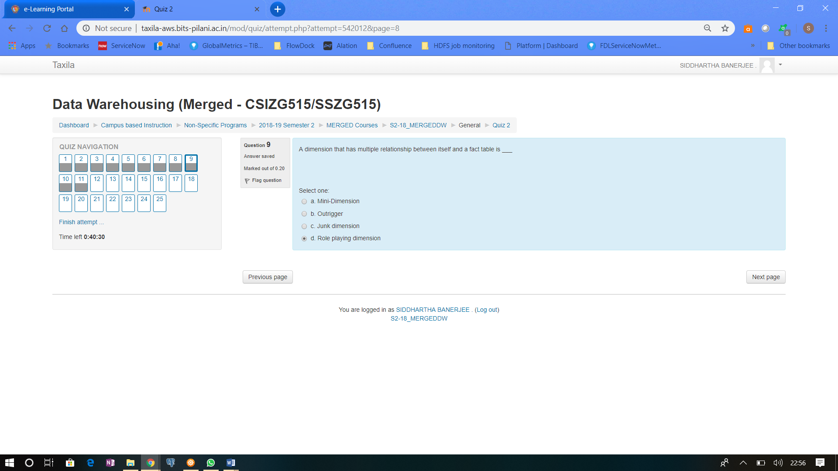

Take for example…Date dimension…in a table there can be Order date, Ship date, Deliver date…Noe Date dimension is having multiple relationship with the fact table

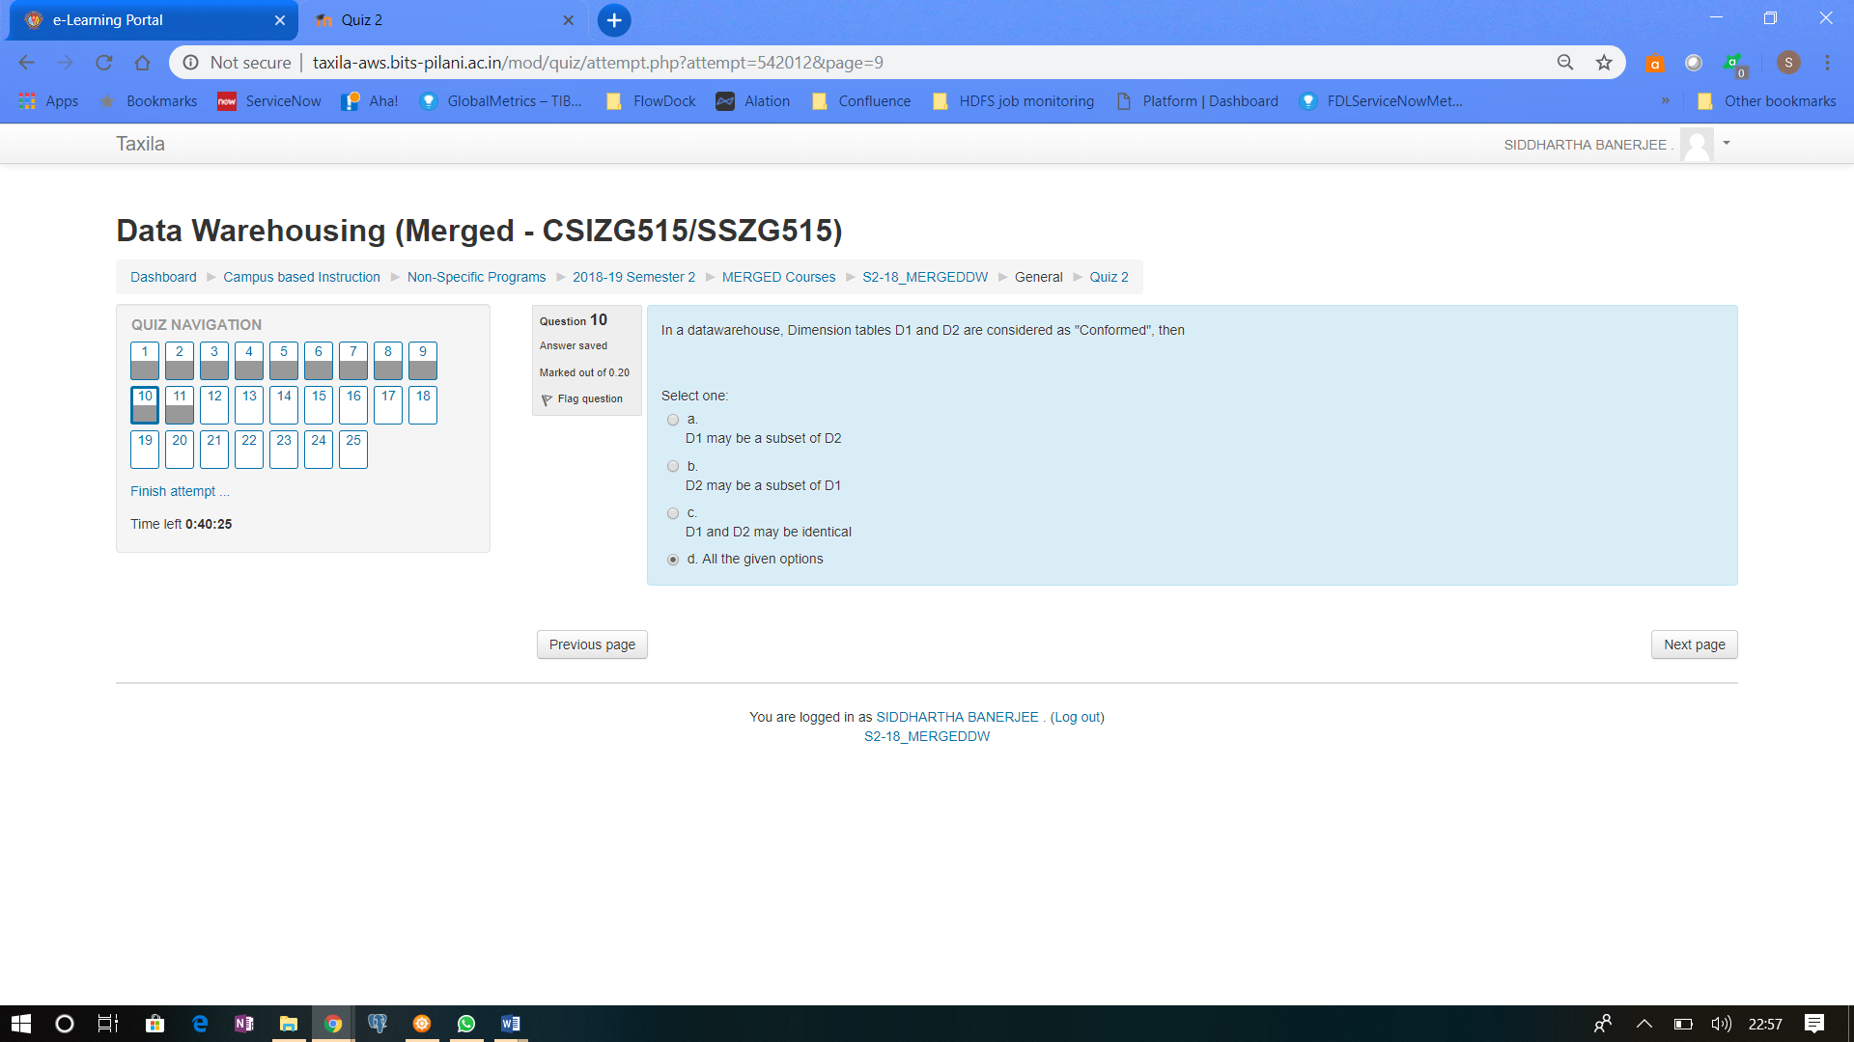

D1 can confirm to D2, or Vice Versa, or D1 & D2 both confirm to another master dimension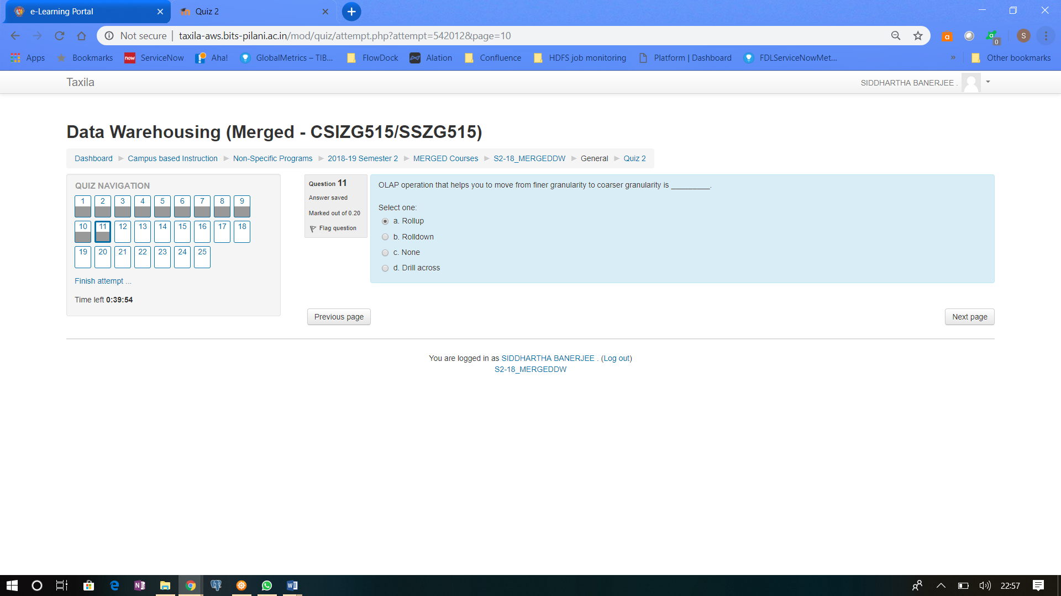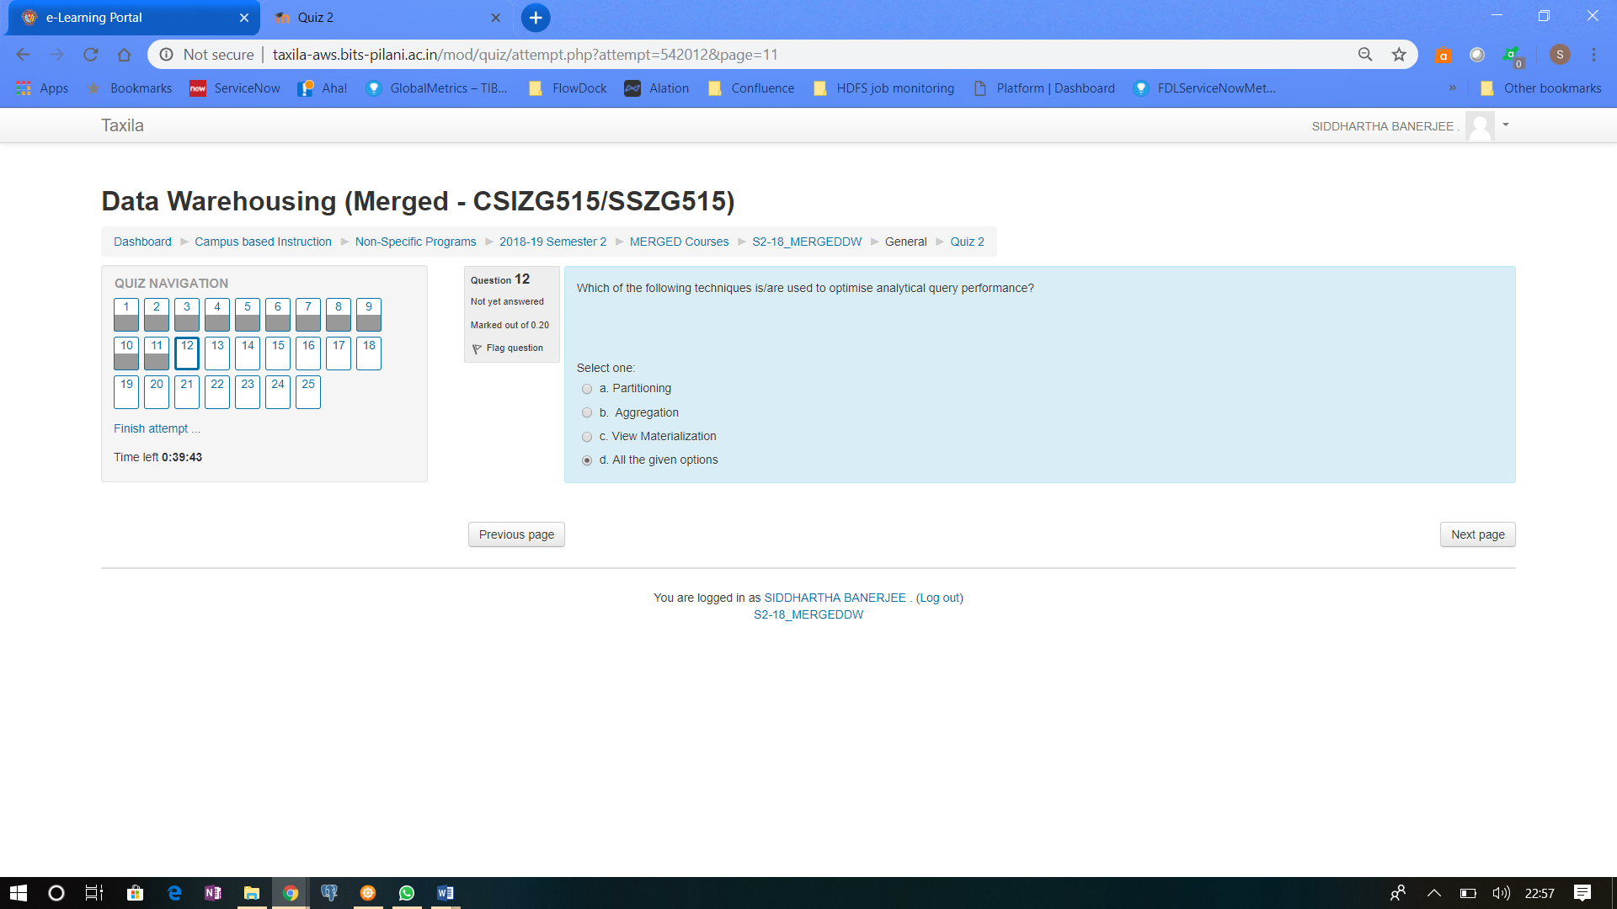

Partition the DB – This limits the query to scan through a smaller DB

Aggregation – The query need not try to do a SUM operation as it is available

View Materialization – The view already has the data..it need not fetch the data from the table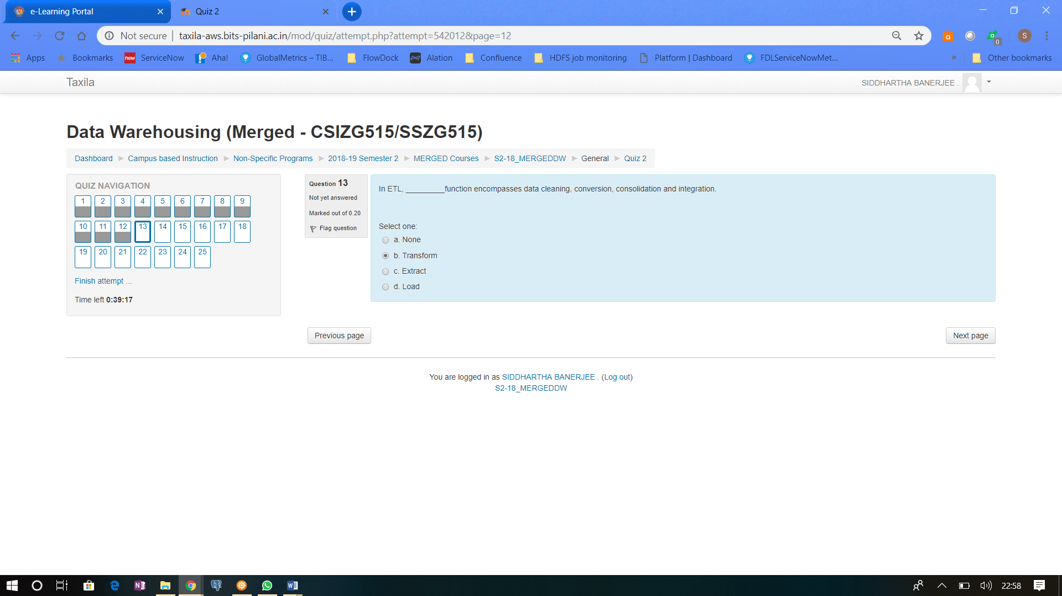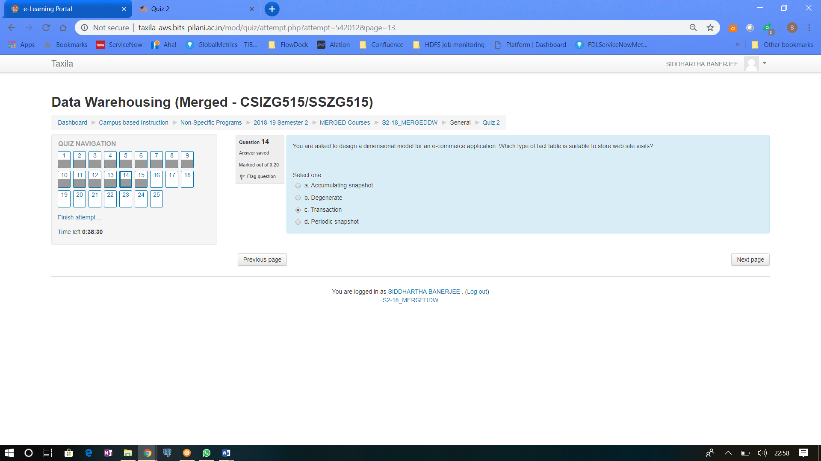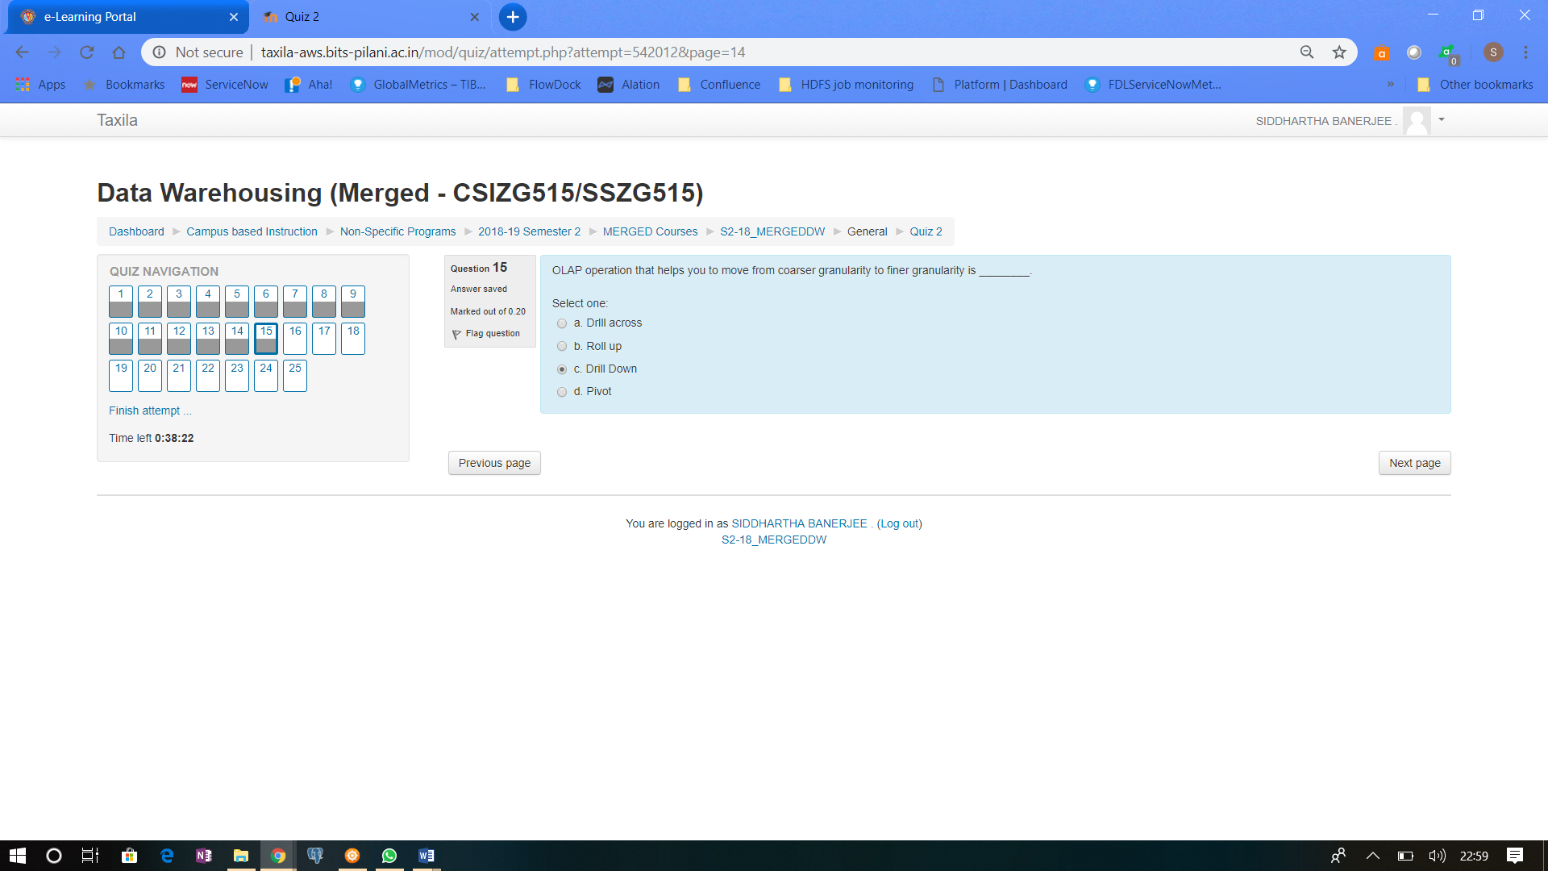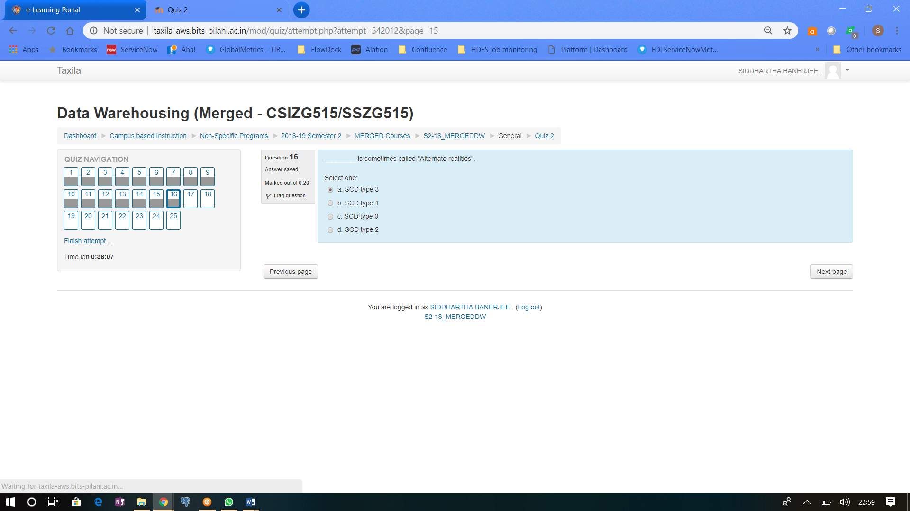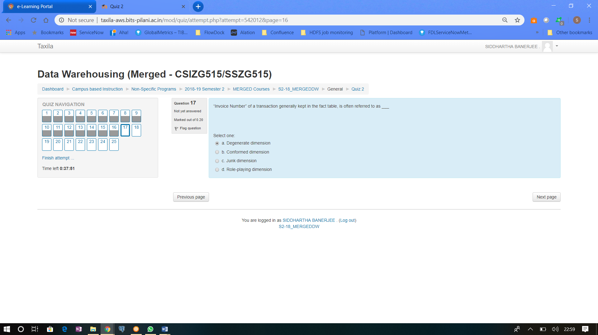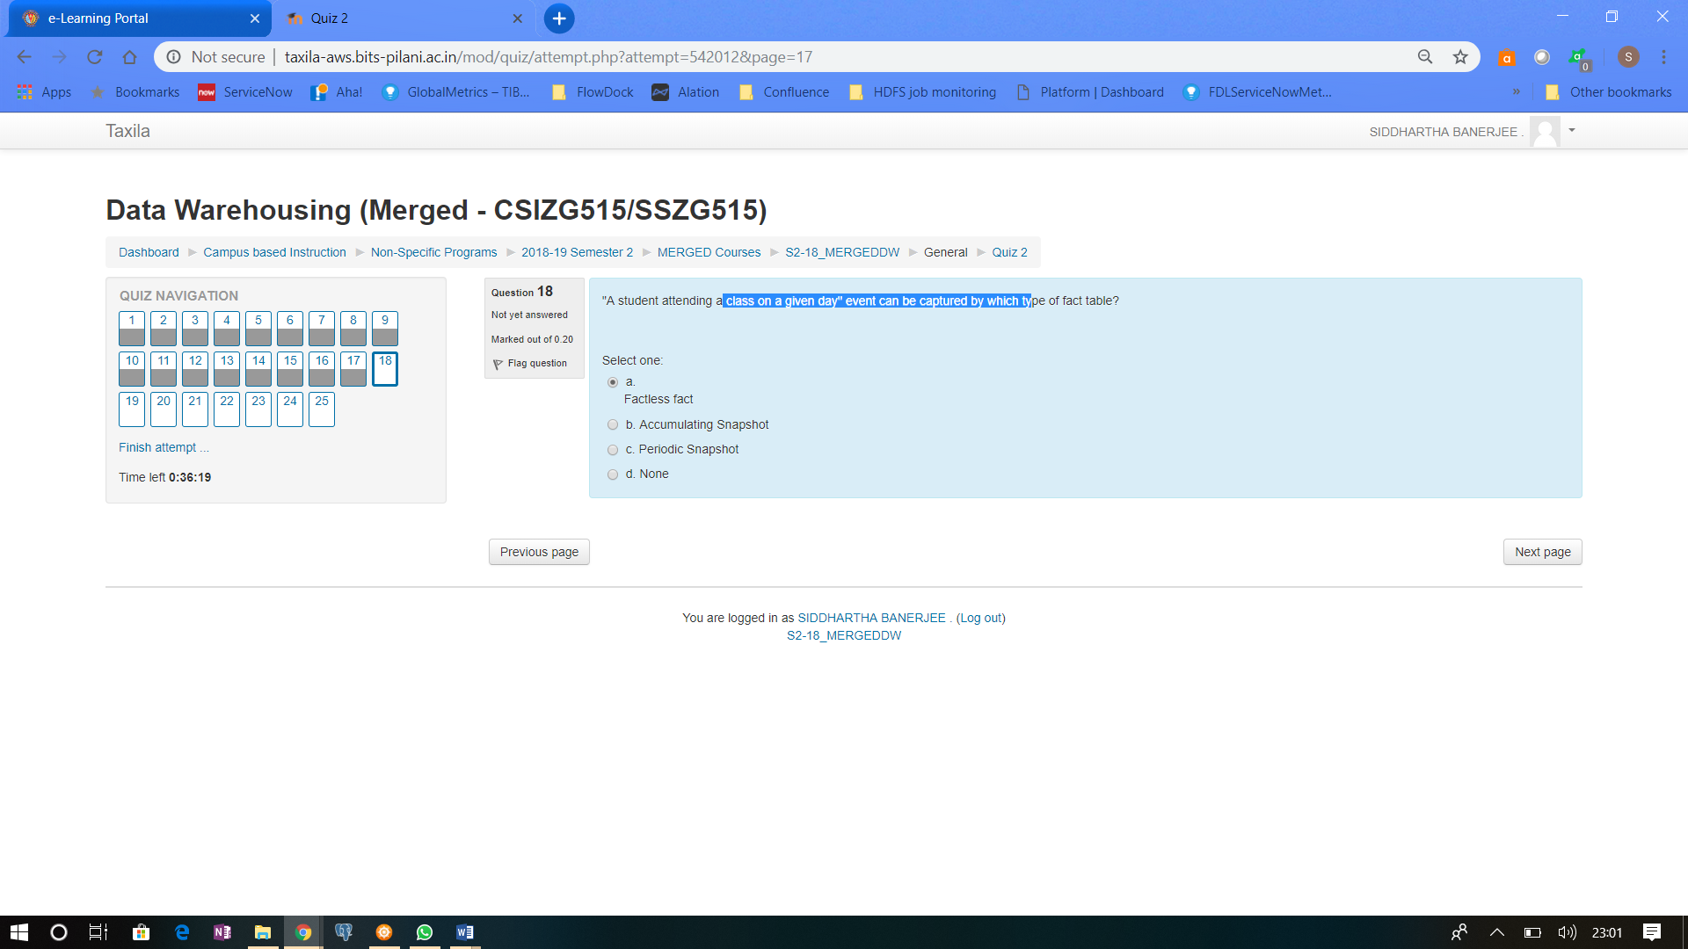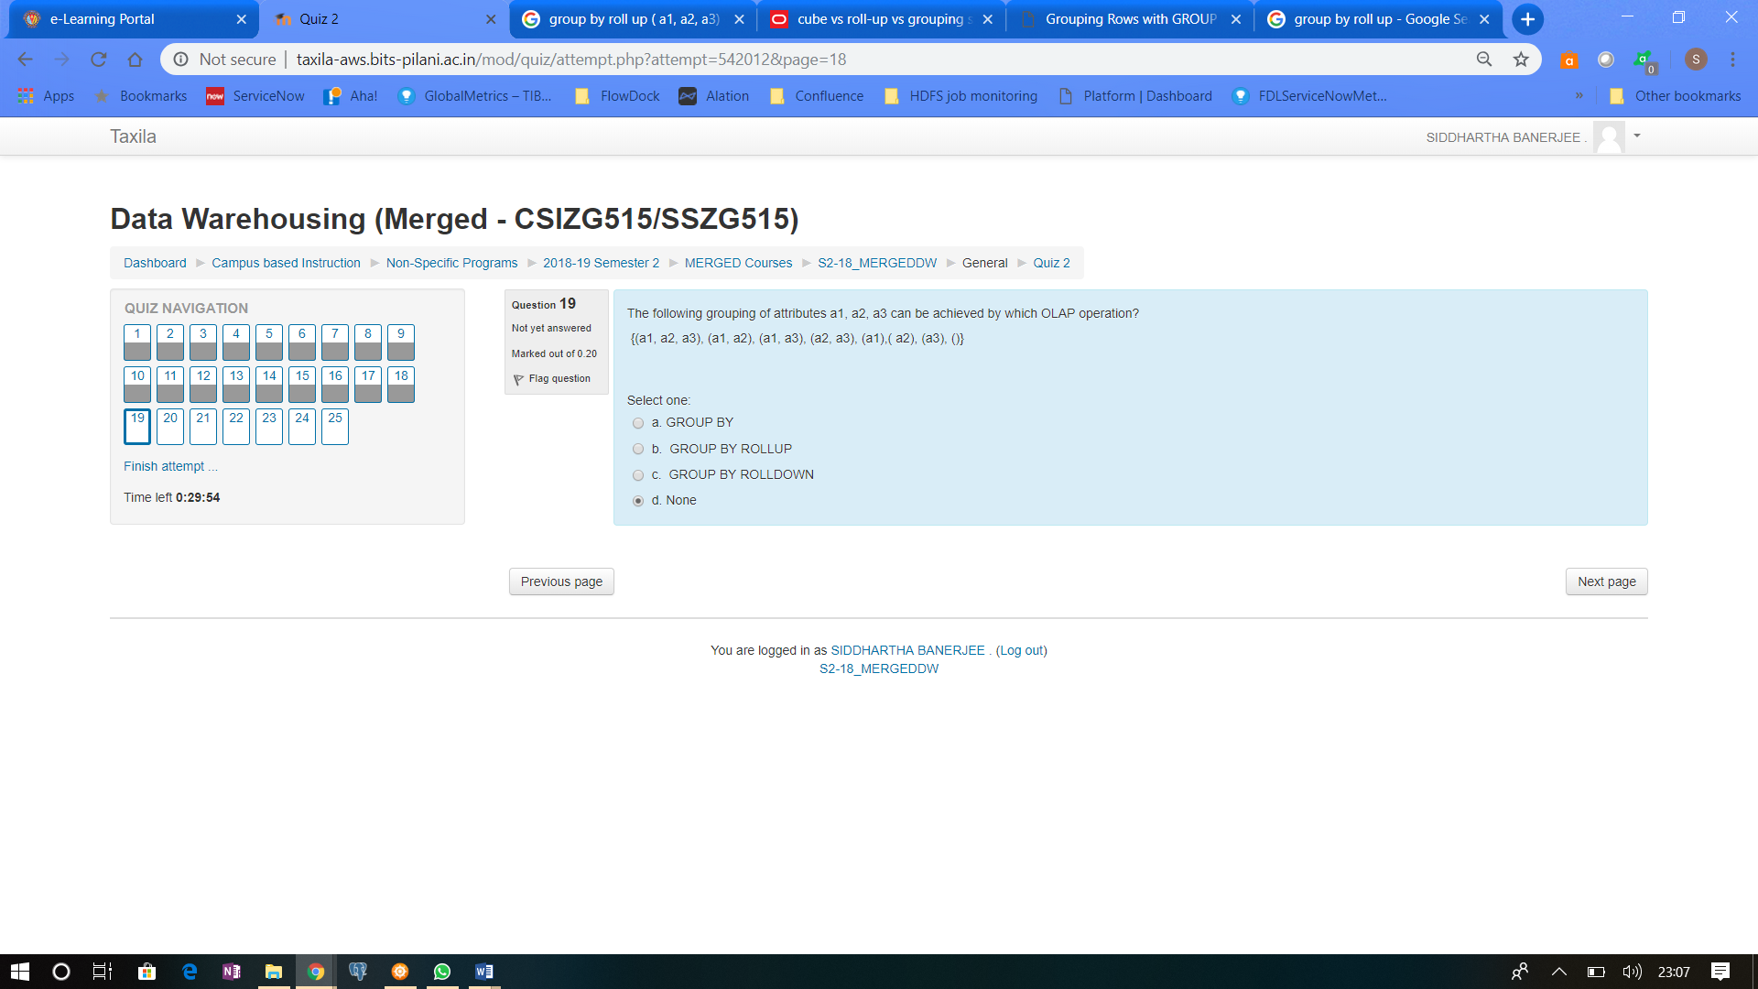

This kind of grouping is give by CUBE

https://oracle-base.com/articles/misc/rollup-cube-grouping-functions-and-grouping-sets

<http://www.sqlservertutorial.net/sql-server-basics/sql-server-rollup/>

he ROLLUP is often used to generate subtotals and totals for reporting purposes.

Let’s consider an example. The following CUBE (d1,d2,d3) defines eight possible grouping sets:

|  |  |
| --- | --- |
| 1  2  3  4  5  6  7  8 | (d1, d2, d3)  (d1, d2)  (d2, d3)  (d1, d3)  (d1)  (d2)  (d3)  () |

And the ROLLUP(d1,d2,d3) creates only four grouping sets, assuming the hierarchy d1 > d2 > d3, as follows:

|  |  |
| --- | --- |
| 1  2  3  4 | (d1, d2, d3)  (d1, d2)  (d1)  () |

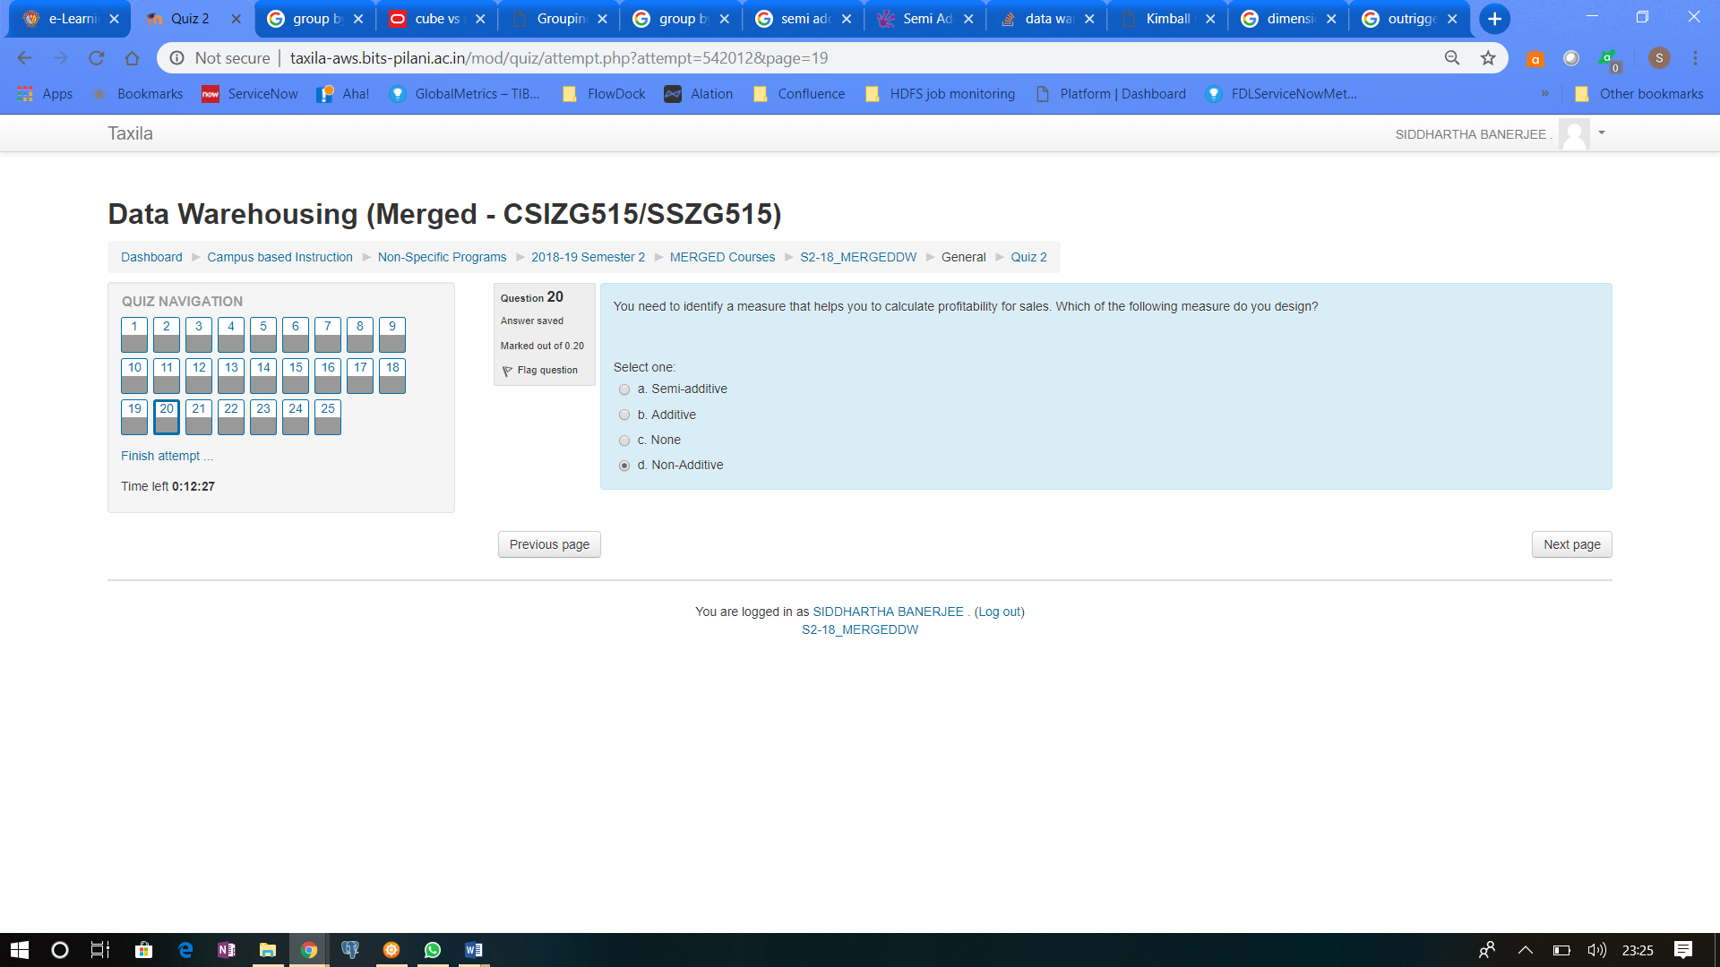 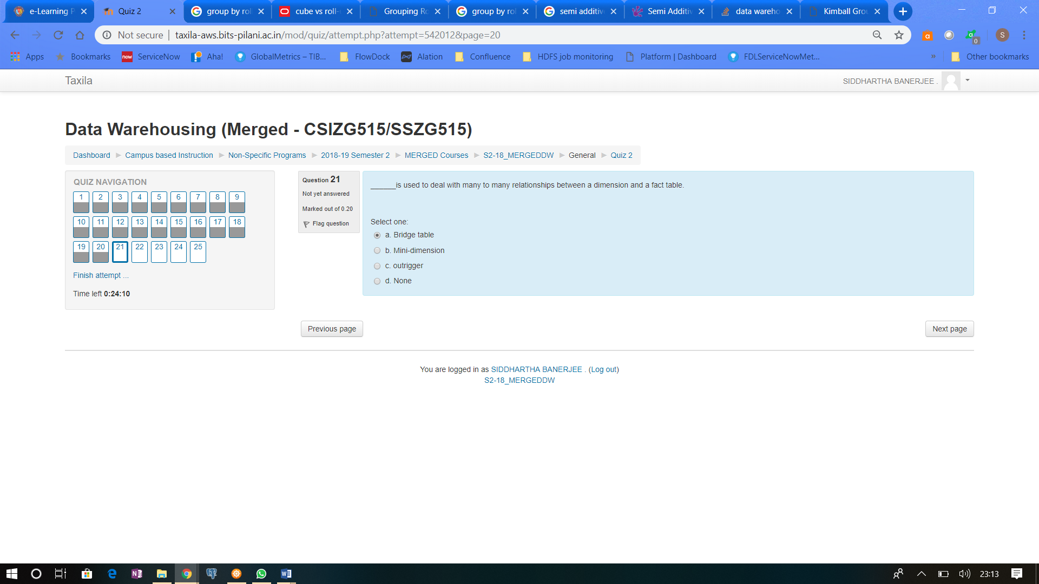

Bridge table helps connect 2 dimension that has many to many relationship…example account number and people…1 account can be held by multiple people, and 1 person can have multiple accounts

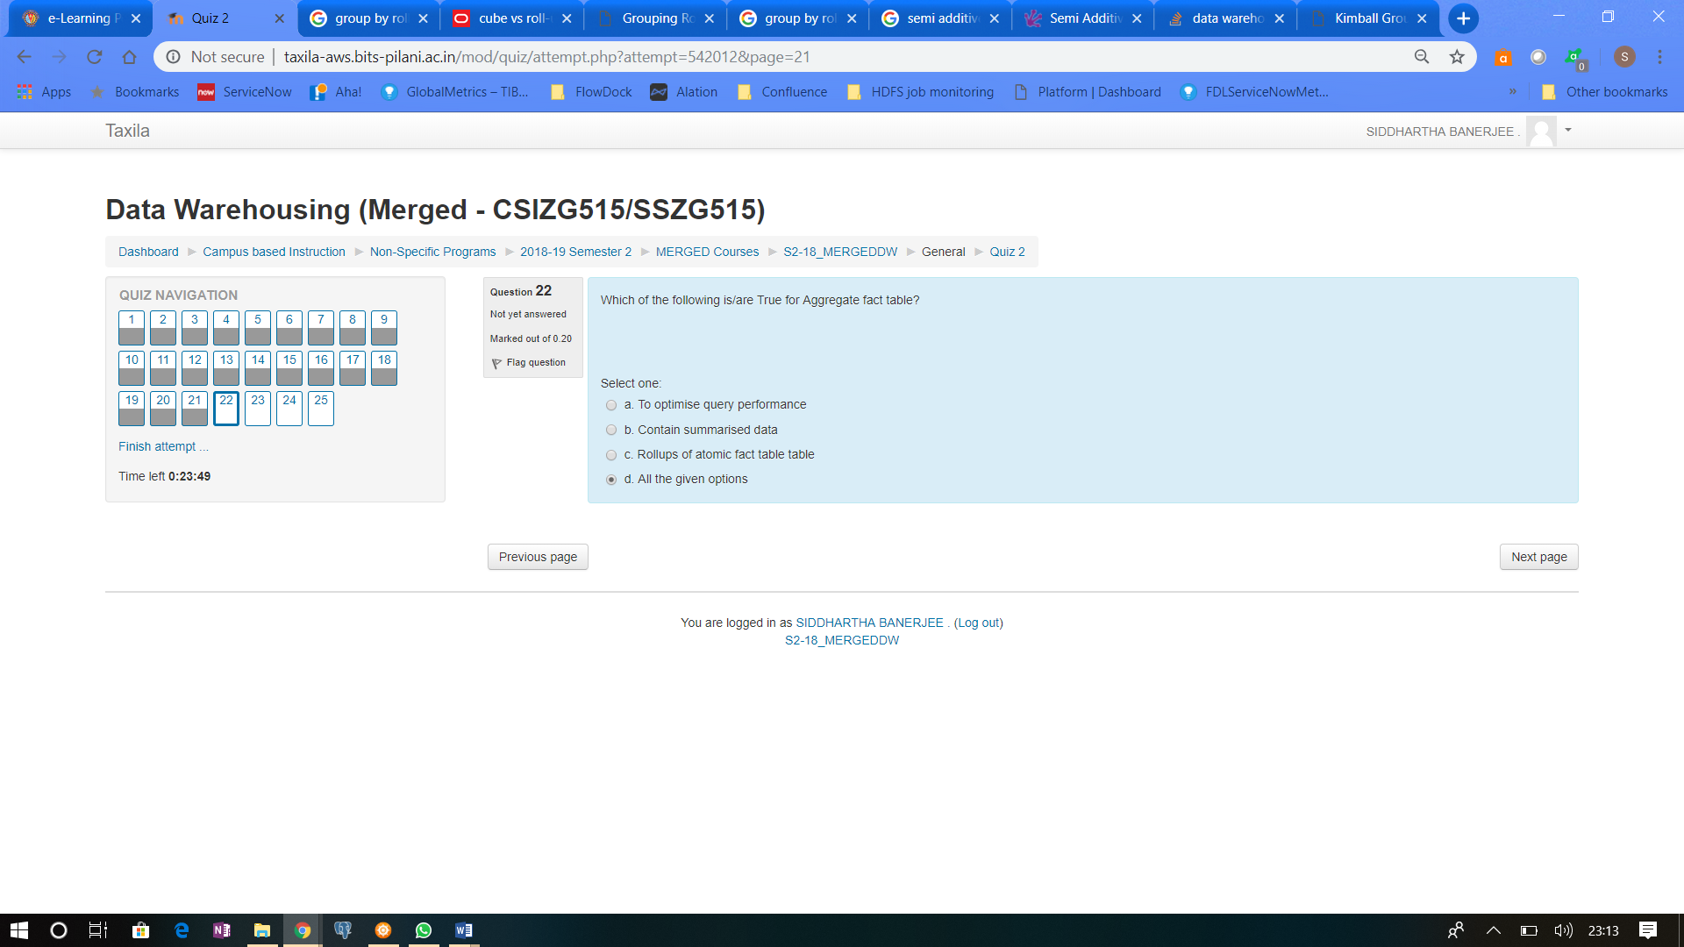

When you aggregate the data, the query is faster, the aggregation by itself produces summarized data, aggregation means roll up of data

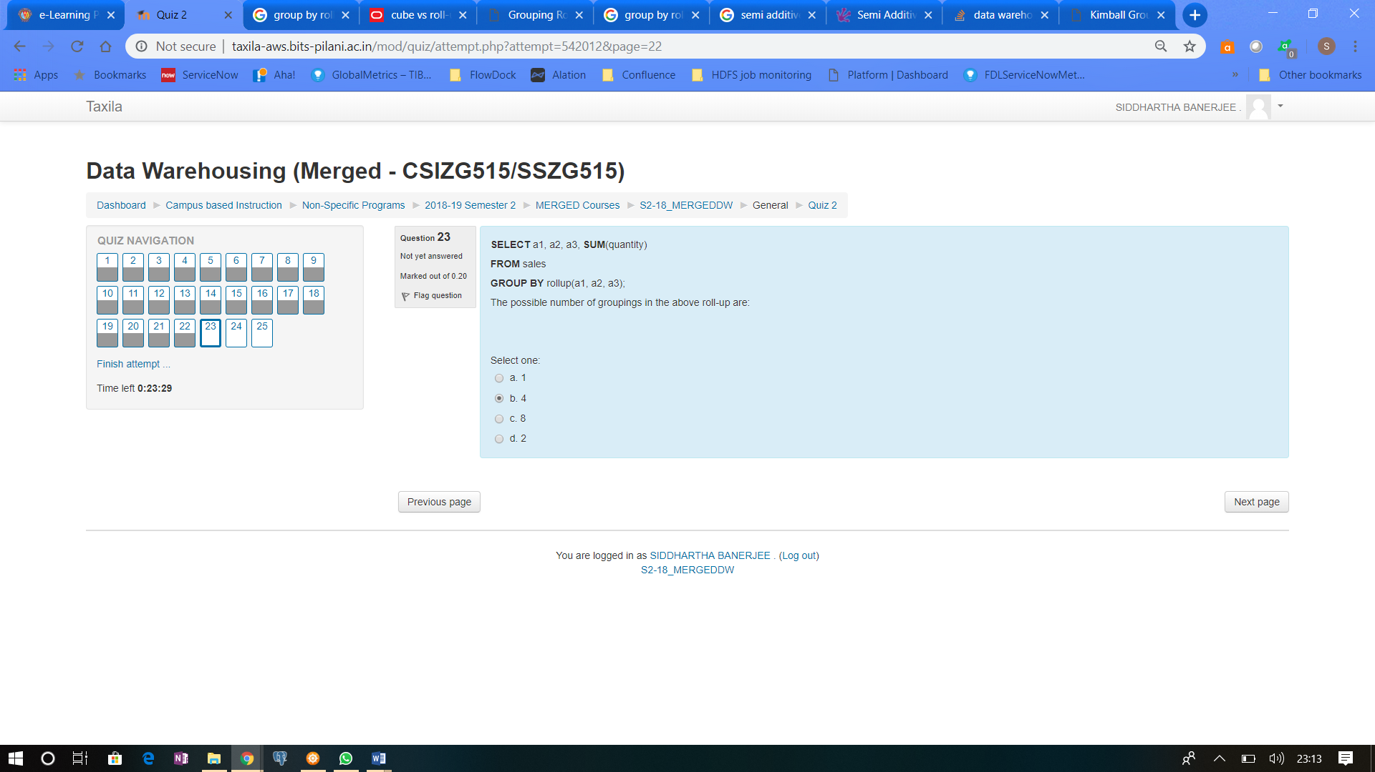

Refer to question 19 above

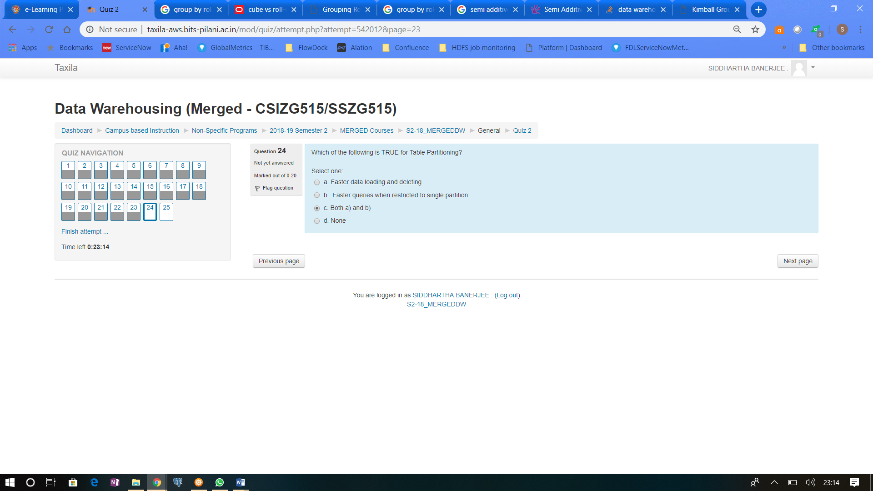

When you partition a table, the query executes faster if the data is within 1 partition and you mention the partition …like year partition…the query states that fetch from year 2019, and the table is structured by year, so it can skip all year checks, and directly jump to 2019 partition …this also results in faster data loading & deleting where you work only that particular partition 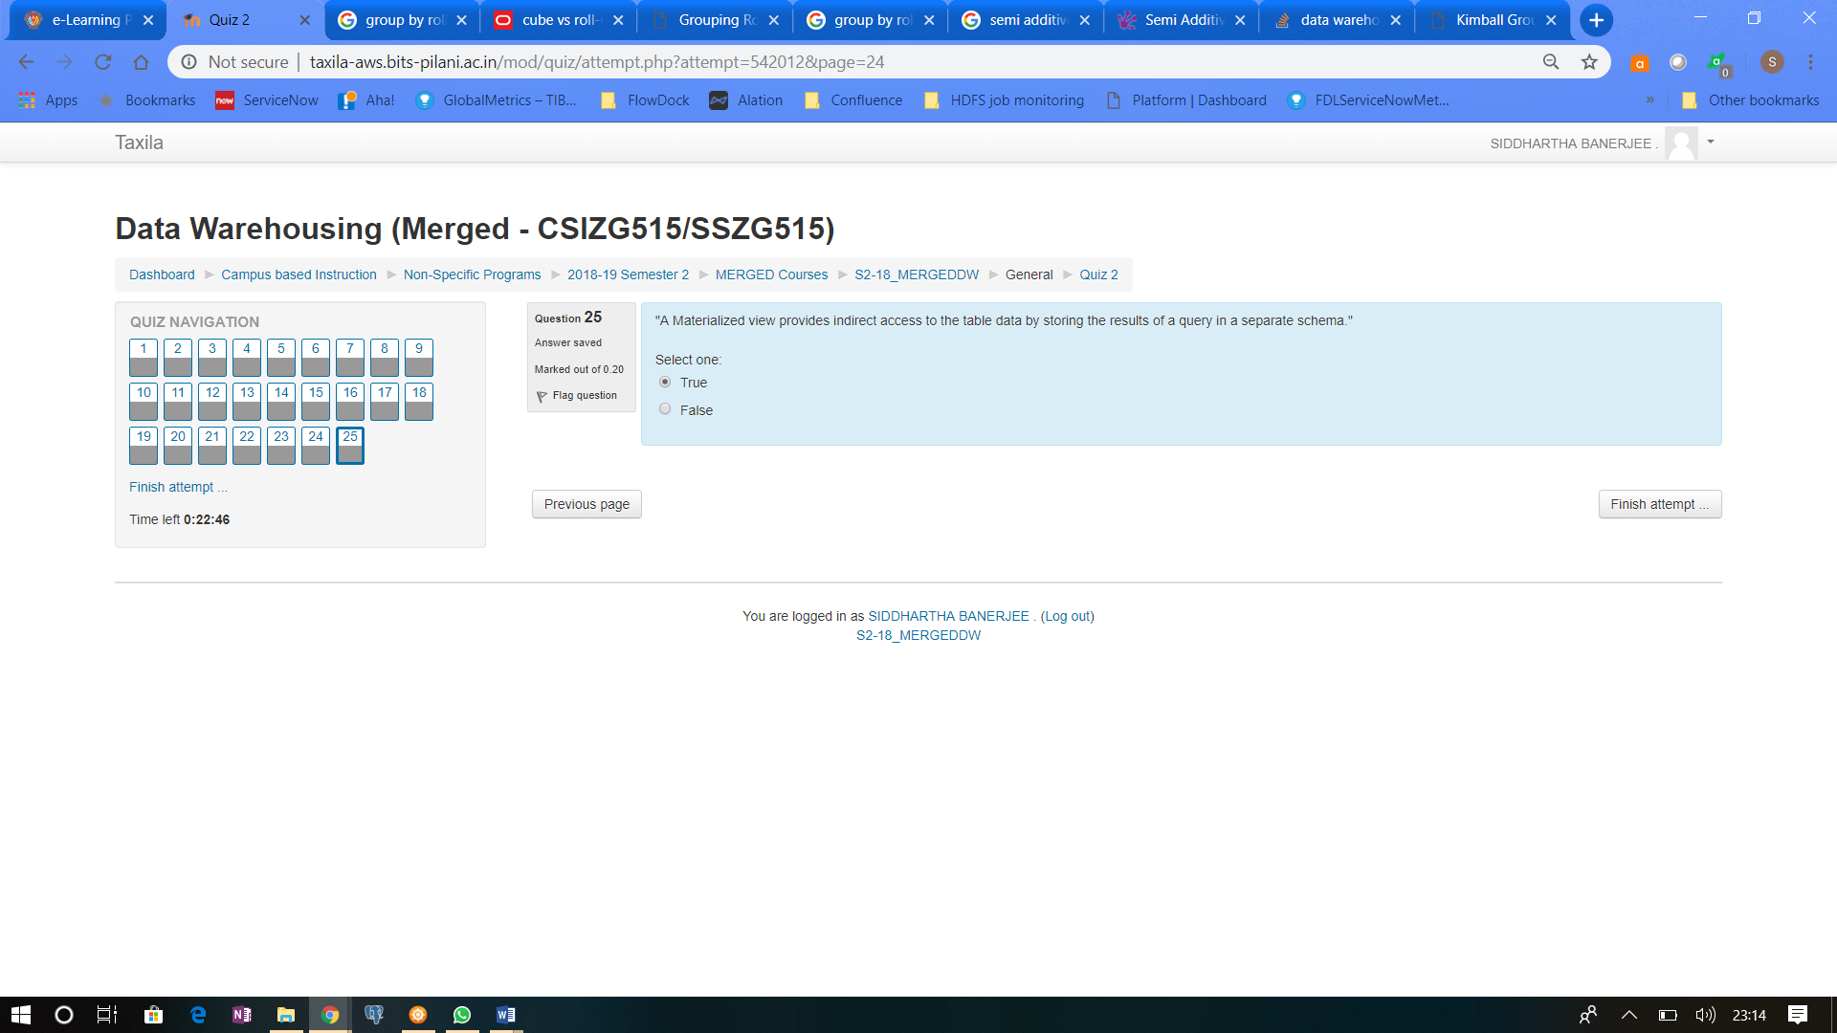

Other attempts questions by BITS folks